2017性別與科技國際會議

2017 International Conference on Gender in Science & Technology

訂房表格Reservation Form Reservation Code:N0172 優惠期間 Period：2017/10/27-10/28
Please fill out the form and fax/mail to Han-Hsien International Hotel
請傳真或E-mail至寒軒國際大飯店Fax: +886-7-330-9803/E-mail: rv@hanhsien.com.tw
Booking訂房【 】 Update更新【 】 Cancel取消【 】
入住日期：  Arrival Date |  |  | 住客姓名：  Guest Name
退房日期：  Departure Date |  |  | 電子郵件：  E-mail
入住人數：  No. of Guests |  |  | 電話：  Tel
房 型Room Type  (All room type: http://www.han-hsien.com.tw/hhih/index.php |  |  |  |  | 優惠價/台幣  Special Rate/NT | 間數  Room No
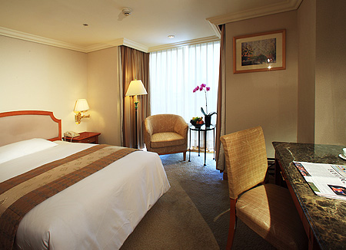 |  | 標準單人客房 一大床 8坪  附贈一客早餐  【Wi-Fi FREE】  Standard Single  140*200cm 26.4m²  Including 1 Breakfast |  |  | NT$2,000NET | 【 】Rm(s)
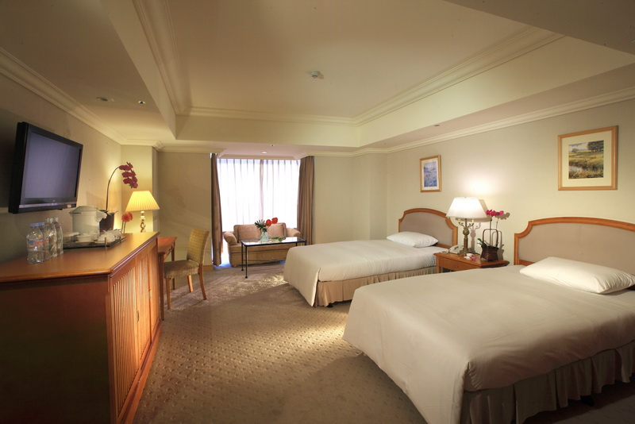 |  | 豪華雙人房 二小床 12坪  附贈二客早餐  【Wi-Fi FREE】  Deluxe Twin  120*200cm 39.6m²  Including 2 Breakfasts |  |  | NT$2,900NET | 【 】Rm(s)
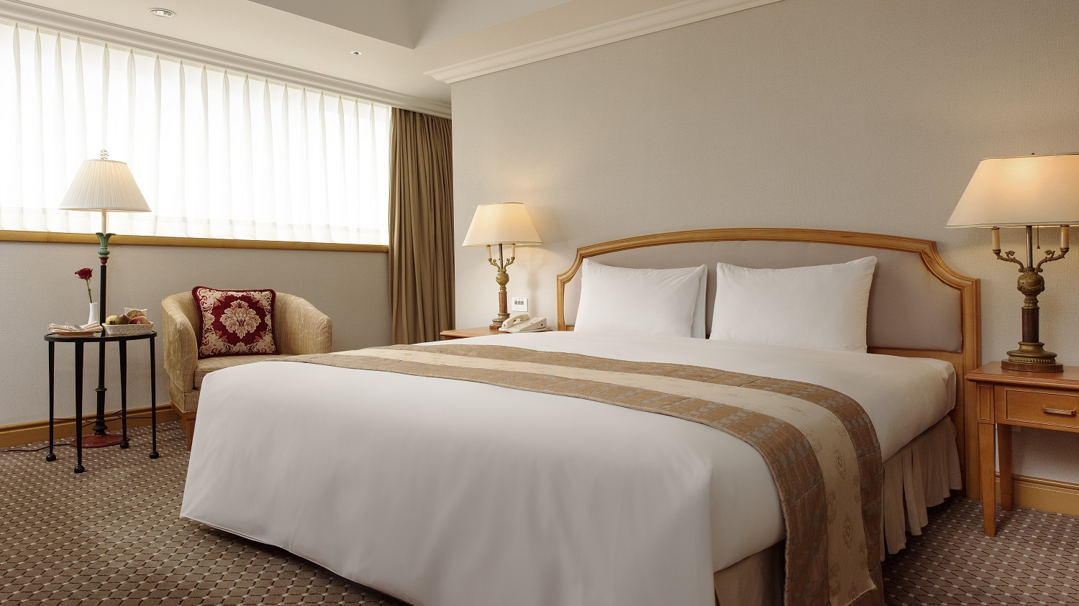 |  | 商務客房 一大床 10-11坪  附贈1客早餐  【Wi-Fi FREE】  Superior King  190*200cm 33-36.3m²  Including 1 Breakfast |  |  | NT$2,600NET | 【 】Rm(s)
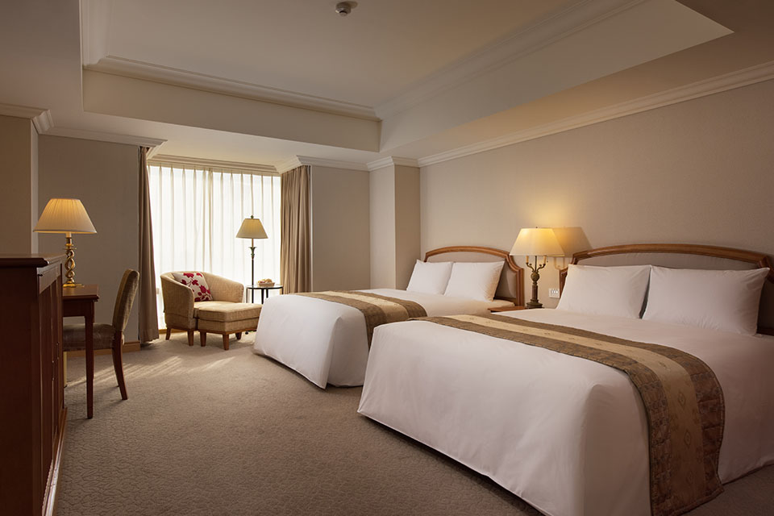 |  | 甜蜜家庭房 兩大床 12坪  附贈2客早餐  【Wi-Fi FREE】  Panoramic King  160*200cm 36.3m²  Including 2 Breakfast |  |  | NT$4,200NET | 【 】Rm(s)
接駁服務  Shuttle Bus  (*pre-booking is requested.*) | * we will provide shuttle Bus service to KHH airport, HRS Zuoying and Sanduo Shopping District Station . Adjust the departure time depending on the booking status.  ** Free Shuttle bus pre booking is requested.**  我們提供免費巴士接駁服務小港機場，左營高鐵，以及三多商圈捷運站。  *From 10/27 to 10/28 On –schedule shuttle bus from Hotel and SYSU for free.  提供10/27-10/28 每日定時定點接駁巴士至中山大學以及寒軒往返。  以上免費接駁為定時定點需事先預約。  ★HSR Zuoying高鐵左營站→Hotel飯店： □9:30、□16:00Departure出發  Hotel飯店→HSR Zuoying高鐵左營站： □9:00、□15:30Departure出發  ★ Kaohsiung Airport高雄小港機場→Hotel飯店： □10:30、□16:00Departure出發  Hotel飯店→Kaohsiung Airport高雄小港機場： □10:00、□15:30Departure出發  Outside of time, car rental(one way) cost: NT$700(1~2Persons)；NT$1,200(3-6Persons).  - Please make an appointment in advance.  ★ Kaohsiung Airport or HRS Transportation Service：□No □ Yes（please reserve one day before）Price：□NT$770+10%/per car (2 persons limited) or □NT$1,320+10%/one way(6-Seat Bus).  Flight or train No.： ， Arrival（or Departure）Time：  時間以外如需租車服務，高雄小港機場或高鐵左營站接送服務費用：  1~2人一趟NT$770+10%元，3~6人座一趟NT$1320+10%元。
Terms &  condition | Check -in time: 3:00 pm check-out time 12:00 at noon.  Free access for the following health club facilities (swimming pool, gym).Free WIFI.  *入住時間每日下午三點，退房時間為隔天中午12點。  *住客可免費享用飯店游泳池，健身房以及免費WIFI。
** I will guarantee my reservation with:
please be advised that reservation will only be confirmed given the following information
訂房保證  Guaranteed. | - After Oct 20, 2017, any cancellation received will result a one-night cancellation charge. In the event of no-show on the arrival date, the full penalty equivalent to the entire duration of the stay booked will also be charged accordingly.  如在2017/10/20後取消訂房，我們將收取一個晚上的罰金。如無通知或惡意取消，  我們會收取預訂住宿期限的全額罰金。  - The confirmation letter will be sent via fax or email within 2 days.  訂房確認單會在兩天後使用傳真或mail方式發送。
Credit Card No:  (Guarantee only) | --- EXP : /
訂房代號  Confirmation No. |  |  |  | 訂房員  Receptionist

